FAHN 2019 ANNUAL CONFERENCE

JUNE 10-14, 2019

This year’s FAHN conference will be held on the beach in Daytona Beach.

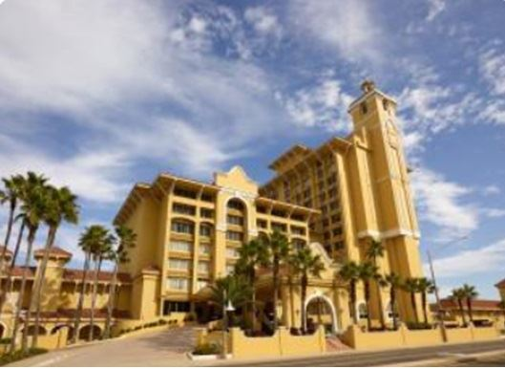
FAHN is again delivering high quality training sessions by engaging speakers!

Breakout sessions will ensure you are able to choose your own program and much of the content will be available in parallel presentations.

Select the "Conference Itinerary" tab to the left side of the Conference page on our website and look at the full program on tap.

Look forward to a fun week of case studies, specialized instruction, and discussions, which are sure to add significantly to your toolbox.

For FAHN members, Registration this year is $250.00 for those who register before April 15 and $300.00 for those after. So register early (before April 15) and save $50.00. See the link on our website for hotel reservations.

Register on-line by going to: www.fahn.net

For more information, contact:

Liz Bradshaw
FAHN Secretary
P.O.BOX 781861
Orlando, Fl 32878
EBradshaw@fortlauderdale.gov
561.271.2962

