Florida Association of Hostage Negotiators  for those who make the call…  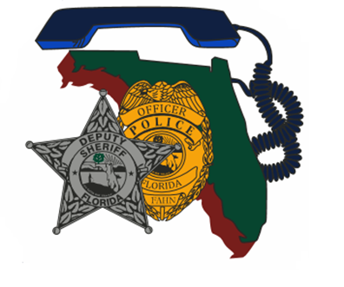  April 19, 2023 0900 Hours  Negotiating With the ideologically Motivated  8:30a-9a Registration and refreshments  9a-1145a Course Presentation  1145a-1p Lunch on your own  1p-5p Course Presentation/Case Study/Certificates  Training Description:  This training is designed to prepare negotiators in negotiating with the ideologically motivated subject and determining strategies for an ideologically motivated person.  Training Topics Include:  - How Ideologically Motivated Subjects Differ from Traditional Emotional vs Rational Subjects  - Common Ideological Motivations with Real World Examples  - A Practical Model for Designing Negotiation Strategy for an Ideologically Motivated Subject  - Case Study of a Negotiation with an Ideologically Motivated Subject | Join us for a presentation on Negotiating w/ the Ideologically Motivated  ────  ────  Speaker: Charles (Chuck) Crosby  Communication Cynergy  Hosted by: Sgt.  David M Garcia  Davie PD  FAHN Region 10 Director  For Questions:  DGarcia@Davie-FL.Gov  954-693-8086  FDLE MiamI  EOC Classroom  1030 NW 111th Ave  Miami, FL 33172  Wed, April, 19, 2023 @ 0900  This training is free for FAHN members and $20 for non-members (price of new membership)

