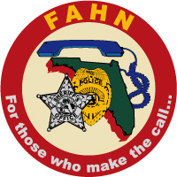

FAHN Region 5 & 7 Training

Date: Thursday March 8, 2018 Time: 8 AM- 5 PM
Registration: 7:30-8:00 AM
Location:
Hillsborough County Sheriff’s Office
Falkenburg Road Jail Assembly Room
520 N. Falkenburg Rd Tampa, Fl 33619

Course Description:
Law Enforcement and the terrorist threat – A growing trend has been international terrorists taking credit for attacks on U.S. soil. As law enforcement officers, we must be prepared to recognize, respond, and stop these attacks. Attendees will be given an overview on topics to include but not limited to: terrorist ideology and organizations, open source intelligence gathering, and negotiations during a terrorist incident. There will also be a discussion on negotiations teams working with EOD teams, and how both teams can work together during an incident involving an IED or other types of explosives.

Instructors:
Dr. Wayman Mullins – Texas State University and co-author of Crisis Negotiations
Col (ret.) Paul Mullin – Retired U.S. Army Special Forces and Chief of Psychological Operations
Master Deputy Marc DeSourdy – HCSO Bomb Team – Team Leader
**********************************************************************************
Registration information:
Contact: Email: djohn@hcso.tampa.fl.us or jcarver@highlandssheriff.org
Check or update your membership status on the website: www.fahn.net
All FAHN Members are FREE!
$20 for non-FAHN members

