Florida Association of Hostage Negotiators  for those who make the call…  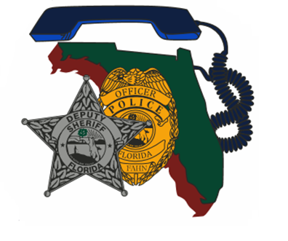  November 9th -13th 2020  Hostage Negotiations Level I  This course will provide the hostage negotiator with the skills needed to resolve a situation involving a hostage taker, barricaded subject or suicidal individual.  Participants will gain familiarity with the dynamics of hostage taking and types of individuals and situations often encountered. The training, when combined with previous experience, will enable the participant to respond successfully to a hostage incident, to better communicate with hostage-takers, and preserve the life of the hostage.  Course Topics Include:  Negotiation Overview, Guidelines and Responsibilities, Behavioral Profiles, Personnel and Equipment Resources Negotiations: Initial Response and Setup, Information Gathering, Strategy and Technique, Stress Management, and Practical Exercises.  There is no charge for this course  <<  <<  << * add any other necessary notes such as parking, etc..*>> | Join us for Hostage/Crisis Negotiation Level 1  ────  Hosted by:  Jim Goodman Seminole County Sheriff’s Office CNT  FAHN Region 6 Director  This Training May Be Used For Salary Incentive or Mandatory Re-training  Contact Me Directly for Registration and Questions  jgoodman@casselberry.org  321-279-9339  Seminole County Sheriff’s Office Training Depot  2772 Depot Av  Sanford, Fl. 32773  Monday November 9th 0900-  Friday November 13th 1700

