Florida Association of Hostage Negotiators  for those who make the call…  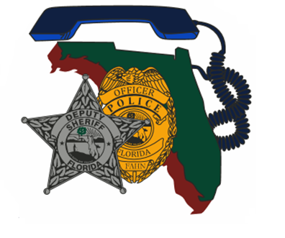  February 20, 2020 0730-1700  “Negotiating with the violent true believer”  730a-8a Registration and refreshments  8a-1130a “Negotiating with the Violent  True Believer”  1130a-12:30p Lunch (Provided)  12:30p-1p Team Preparation  1p-4p Scenario  4p-5p Scenario Debrief  Crisis Systems Management will be providing a  2 hour lecture on “Negotiating with the Violent True Believer”. We will then break for lunch, which will be provided. After lunch we will move into team scenarios, so please ensure your team brings your Command Buses and equipment. There will be plenty of parking to accommodate.  Please register at FAHN.net by February 15, 2020  For questions, contact Region 1 Director, Nesli Suhi-Moore at nsuhi@sheriff-okaloosa.org. | Join us for  Region 1 Training  ────  “Negotiating with the Violent True Believer”  ────  Speaker:  Crisis Systems Management  Hosted by:  Nesli Suhi-Moore  Okaloosa County Sheriff’s Office  FAHN Region 1 Director  For Questions:  nsuhi@sheriff-okaloosa.org  850-259-0091  Crestview community center  1446 Commerce Drive  Crestview, FL 32539  February 20, 2020

