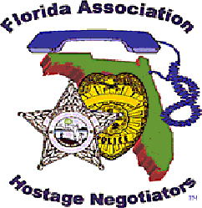  September 7, 2018 0800-1700  PTSD: Engaging Veterans in Crisis  730a-8a Registration and refreshments  8a-1145a PTSD  1145a-1p Lunch on your own  1p-2p Veteran Suicide  210p-3p Trauma informed care organizations  3p-430p Scenarios  “You can’t wade across a river and not get wet”  Nearly 3,000 men and women have now served in Iraq and Afghanistan. Many of these warriors will return home with both physical and invisible wounds of war. Family members and personnel working with veterans often feel ill equipped to effectively engage a veteran struggling with Post-Traumatic Stress Disorder (PTSD). This training will provide a comprehensive understanding and conceptual framework of PTSD, which will facilitate the development of effective strategies for engaging Veterans in crisis. We will also examine Veteran suicide and Veterans Affairs prevention strategies. Participants will be exposed to engagement tools that will increase the chance of a favorable outcome for everyone involved when engagement is inevitable.  *Parking is available free of charge in the college parking garage* | Join us for an in-depth look at PTSD: Engaging Veterans in Crisis  ────  We will also discuss how trauma informed organizations can impact criminal justice outcomes  ────  Speaker: Patrick Diggs, LCSW  C.W. Bill Young VA Medical Center  Hosted by: Amanda Newton  St. Petersburg Police Department  FAHN Region 5 Director  St. Petersburg College  Downtown Campus  244 2nd Ave North  St. Petersburg, Florida 33701  (727) 893-9584  www.spcollege.edu  September 7, 2018, 8am-4pm

