Florida Association of Hostage Negotiators  for those who make the call…  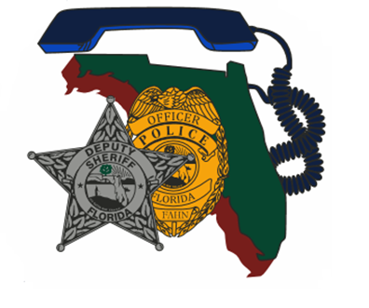  Region 7/5 Joint Training March 6, 2020 0800-1700  “Going Postal"  &  “Working Together EOD/CNT/SWAT”  0800 - 0830 Registration and refreshments  0830 – 1200 “Going Postal” Case Study by D/S Carrie Renninger and Sgt. John Finley  1200 - 1330 Lunch on your own  1330 – 1700 “Working Together…EOD/CNT/SWAT” Case study and presentation by Maj. Brandon Ball  D/S Renninger and Sgt. Finley of the Manatee County Sheriff’s Office, will present a case study regarding a retired US Postal Service employee. This subject was pending eviction from his MHP and took the manager of the park hostage. They will discuss the roles of both of their teams and tactics used to reach a successful outcome.  During the afternoon session, Maj. Brandon Ball from the Bureau of Fire, Arson, & Explosives Investigations, will present an overview of the value EOD teams can provide when operating with CNT and SWAT. The presentation will include real life case studies of successes and failures of EOD operators while assisting at barricaded subject calls, hostage scenes, and violent perpetrator apprehension. The presentation will also include an overview of the technology EOD teams bring to the table such as communications, robotic operations, and intelligence gathering. | Join us for  “Going Postal”  And  “Working Together”  ────  Speakers:  Morning  D/S Carrie Renninger HNT and Sgt. John Finley Co-Commander SWAT  Manatee County S.O.  Afternoon  Major Brandon Ball Division of Investigative & Forensic Services  Bureau of Fire, Arson, & Explosives Investigations  Hosted by:  D/S Chris Carr  Highlands County S.O.  FAHN Region 7 Director  For Questions:  jcarr@highlandssheriff.org(863) 840-1703  D/S Carrie Renninger  (941) 737-9886  Manatee County S.O. District 3  616 67th STREET cIRCLE eAST,  bRADENTON, fl.

