Exploring Influence in Crisis Negotiation
September 25, 2020
Speaker Bios and Presentation Synopses:
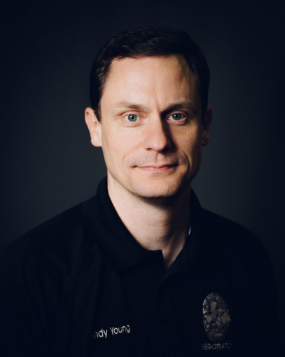
Dr. Andy Young has been a Professor of Psychology and Counseling at Lubbock Christian University since 1996 and a negotiator and psychological consultant with the Lubbock Police Department’s SWAT team since 2000. He also heads LPD's Victim Services Unit and is the director of the department’s Critical Incident Stress Management Team. He has been on the negotiating team at the Lubbock County Sheriff’s Office since 2008, is on the team at the Texas Department of Public Safety (Texas Rangers, region 5), and has recently been asked to serve as the psychological consultant on the Amarillo Police Department’s negotiating team. He is the author of, Fight or Flight: Negotiating Crisis on the Frontline and When Every Word Counts: An Insider’s View of Crisis Negotiations, which contain mostly stories about his work as a crisis counselor and hostage negotiator at LPD (see www.DrAndyYoung.com). He also has published research on the callout experience and on the personality and decision-making styles of negotiators and SWAT operators. Since 2014 he has spoken nationally and internationally at numerous hostage negotiator conferences, as well as other professional and academic conferences on crisis intervention and hostage negotiating.
Dr. Young will be presenting a three-hour compilation of negotiator callout debriefings, focusing on response to depressed and suicidal individuals. The presentation will include a review of negotiation strategies, with specific focus on the concepts of influence and persuasion.
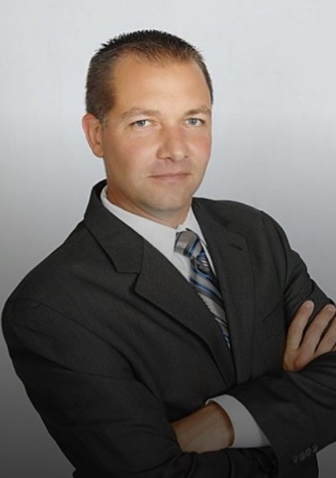
Lieutenant Scott Tillema is a FBI-trained hostage negotiator, spending over seven years as a negotiator with the NIPAS Emergency Services Team, one of the largest multi-jurisdictional municipal SWAT teams in the United States, serving 1.8 million people in the suburban Chicago region. He is currently the training coordinator at the Schaumburg (IL) Police Department, where he has been a police officer since 2002.
Scott is a nationally-recognized speaker in the field of police negotiations, having presented to thousands of police negotiators at conferences across the country. He was invited to give a TEDx Talk, where he presented, “The Secrets of Hostage Negotiators,” and he has been a featured guest on the Negotiations Ninja podcast.
Educationally, Scott holds a master’s degree in psychology and has received negotiation training at Harvard University. For many years, Scott held the role of adjunct professor at a local university, teaching multiple courses in both the psychology and criminal justice programs. He is a faculty member with the Schranner Negotiation Institute based in Switzerland, providing negotiation instruction to clients in both the US and Europe, and he was recently named as a trainer for the Hostage & Crisis Negotiation International Academy, based in Paris.
Scott will be presenting “The Arlington Heights Negotiation Debriefing” – In Arlington Heights, IL, a man had been stalking his ex-girlfriend and tracked her to her mother’s home. Once he got inside, he pulled a gun and started shooting. The mother and her friend escaped and called 9-1-1, leaving the gunman and his ex-girlfriend inside the home. The first responding police officer was shot in the neck by the hostage taker and went down inside the home. As the gunman barricaded himself in the basement with the hostage, the police began negotiations. The SWAT Team was called and continued negotiations, which later included the use of a third-party intermediary. Scott will present this debrief with a focus on the influencing techniques used by negotiators.

