Florida Association of Hostage Negotiators  for those who make the call…  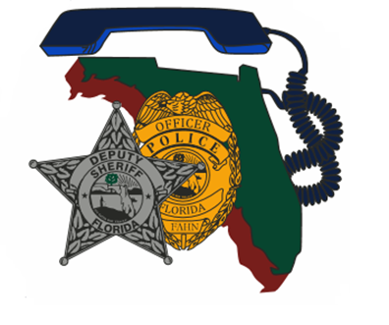  October 24, 2023 08:00-17:00  Region 1 fall training  08-0830 Registration and Refreshments  0830-0845 Break  0845-1130 Presentation  1130-1300 Lunch ON YOUR OWN  1300-1600 Team Scenario  1600-END Closing and Certificate Presentation  Join us for a great and impactful training! We will begin the training day with an instructional block discussing current negotiation trends followed by a scenario for the teams to work through. Please bring your vans/buses/command vehicle and any equipment you want to work with! | Join us for  Fall 2023 Region 1 Training  ────  Instructional block of training surrounding current trends in negotiations followed by a team scenario.  ────  Hosted by: Sergeant Jessica Trimboli  Okaloosa County Sheriff’s Office  FAHN Region 1 Director  For Questions:  jdtrimboli@sheriff-okaloosa.org  850-461-9769  Crestview community center  1446 Commerce Dr, Crestview, FL 32539  Training is free for FAHN members or $20 for non-members (fee includes 1 year membership).  10/24/23 0800-1700

