Florida Association of Hostage Negotiators  for those who make the call…  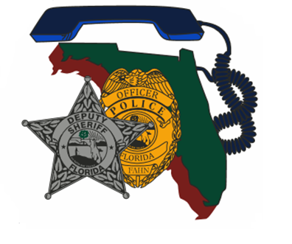  Thursday, October 27, 2022 08:00-17:00  Why Peer support is so important  08-0830 Registration and Refreshments  0830-0915 Welcome, Housekeeping  0930-1130 Presentation  1130-1300 Lunch ON YOUR OWN  1300-1600 Presentation and Break Outs  1600-END Closing and Certificate Presentation  Join us for a great and impactful training presented by one of our own Region 1 FAHN members! The Walton County Sheriff’s Office has implemented a Peer Support Team and we are excited to share how along with the relevance to negotiations, interactive break out sessions, and more.  *Parking will be in the lot across from the main EOC building. You should see other patrol vehicles. If there are questions, call me.* | Join us for  Fall 2022 Region 1 Training  ────  We will also discuss  Establishing a Peer Support Team  ────  Hosted by: Sergeant Jessica Trimboli  Okaloosa County Sheriff’s Office  FAHN Region 1 Director  For Questions:  jdtrimboli@sheriff-okaloosa.org  850-461-9769  Okaloosa County Emergency Management  90 E. College Boulevard  Niceville, Florida, 32578  Training is free for FAHN members or $20 for non-members (fee includes year membership).  10/27/22 0800-1700

