Florida Association of Hostage Negotiators  for those who make the call…  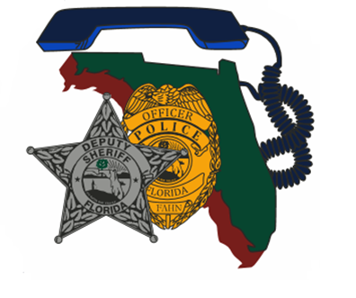  Jan 17, 2024 0900 Hours  Case Study Presentation/Scenario based training  8a-9a Registration and refreshments  9a-1145a Case Study Presentation w/ Corporal James-Potts  1145a-1p Lunch on your own  1p-3p Scenario Based Roleplaying w/ Nova Southeastern  University Psychology Students  3p-4p Current Issues & Concerns  4p-5p Certificates (Electronic) & Dismissal  Corporal Jeffrey James-Potts will present an amazing case study, in which he himself became both hostage and negotiator with an armed gunman. Be prepared to listen to Corporal James-Potts give his recount of this incident, as you watch the incident unfold via surveillance camera footage. An unbelievable case study that you do not want to miss.  Additionally, there will be scenario based training in the afternoon, presented by Nova Southeastern University’s Psychology Department. | Join us for a presentation by: Corporal Jeffery James-Potts  ────  We will also have  Scenario Training  ────  Speaker: Jeffery James-Potts  Orange County Sheriff’s Office  Hosted by: Sgt. David Garcia (Davie PD)  Ft Lauderdale & Davie PD  For Questions:  DGarcia@Davie-FL.Gov  954-693-8086  FT Lauderdale POA Hall  4500 SW 13th St  Ft Lauderdale, Fl 33317  Wed, Jan, 17, 2024 @ 0900  This training is free for FAHN members and $20 for non-members (price of new membership)

