Florida Association of Hostage Negotiators  for those who make the call…  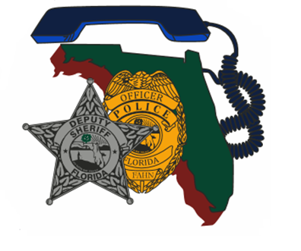  WEDNESDAY, December 6, 2023, 8A-5p  Dual Negotiation Concepts & Scenario based training  Itinerary:  8a-830a F.A.H.N Registration / sign-in and refreshments  830a-9a Opening Remarks / Training Day Remarks Rules  9a-10a Dual Negotiation Concepts  10a-11a Team Building Exercises  (Refreshers on Active Listening &Crisis Response)  1130a-12p Preparation for practical exercises  12p-1p Lunch (on your own)  1p-4p Practical Exercise (Negotiation Crisis/Intervention)  4p-5p Debrief / Closing Remarks  Course Description:  This training is centered on dual negotiation concepts, team building and scenario-based training. The training day will also encompass a refresher on Active Listening and Crisis Response.  **Teams attending training are asked to bring their team negotiation equipment to include but not limited to the following: cell phones, computers, throw phone, negotiation supplies, team vehicle etc.**  ***Training Certificates will be provided electronically*** | Join us for an 8- hour  Dual Negotiations Concepts  ────  Presenter:  Jim McDonald  Hosted by:  Region 2 Director -  Lt. Jason Glover  Leon County Sheriff’s Office  FAHN Region 2 Director  For Questions reference FAHN / Course registration:  gloverj@leoncountyfl.gov  850-556-2930  *Please send a training request up the chain for approval and registration  Location:  Florida Sheriff’s association training center  2617 mahan drive ,  tallahassee, Florida 32308  *Cost to Attend: FREE to FAHN members $20 if Non-FAHN Member

