Florida Association of Hostage Negotiators  for those who make the call…  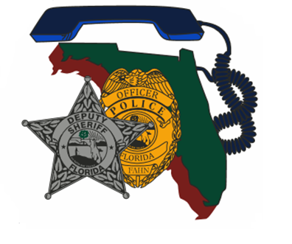  Thursday, April 18, 2024  8:30am – 4:30pm  Training Day Schedule:  830a-900a…….…. Registration / Check-In  900a-930a………... Training Day Expectations  930a-1130a……… Case Study Presentation  1130a-1oop………… Lunch on your own  100p-130p…………. Q&A of case study presentation  130p-330p………. Deconstruction/Open Discussion of Lessons Learned  330p-415p………… Tabletop Correctional vs LE negotiation setting  415p-430p………...Training day wrap up / certificates  If you missed the 2023 FAHN Conference, or if you attended and missed this session, then come join us for this amazing case study! Corporal James-Potts will present his own hostage negotiation experience that involved an armed, barricaded subject, and several hostages, at a detention facility. Corporal James-Potts’ experience exemplifies grit, perseverance, and the importance of a survival mindset!  **This training is free for current FAHN members and $20.00 fee for non-members.**  For any questions or assistance, please contact Jason Glover 850-556-2930 or gloverj@leoncountyfl.gov  REGISTER TODAY @ https://fahn.wildapricot.org/Training  Questions? Call Nancy Marzouk at 352-258-5936 (w. cell) | Instructor:  Corporal Jeffery James-Potts  Orange County Sheriff’s Office  Hosted by:  Lt. Jason Glover Leon County Sheriff’s Office / FAHN Region 2 Coordinator  Location:  Leon County Sheriff’s Office  2825 Municipal Way  Tallahassee, FL 32304

