Florida Association of Hostage Negotiators  for those who make the call…  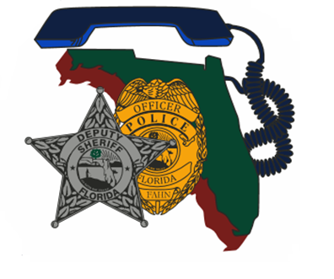  JANUARY 4, 2022 from 0800-1700  NEGOTIATING WITH THE IDEOLOGICALLY MOTIVATED  Itinerary:  8a-830a F.A.H.N Registration / sign-in and refreshments  830a-1145a Course Presentation  1145a-1p Lunch on your own  1p-5p Course Presentation Cont. / Case Study / Closing  Course Description:  This course is designed to prepare negotiators in negotiating with the ideologically motivated subject and determining strategies for an ideologically motivated person.  Training Topics Include:  - How Ideologically Motivated Subjects Differ from Traditional Emotional vs Rational Subjects  - Common Ideological Motivations with Real World Examples  - A Practical Model for Designing Negotiation Strategy for an Ideologically Motivated Subject  - Case Study of a Negotiation with an Ideologically Motivated Subject  ***Certificates will be provided following the training*** | Join us for an 8- hour Negotiating with the Ideologically Motivated Training  ────  Presenter:  Charles (Chuck) Crosby  Communication Cynergy  Hosted by:  Region 2 Director -  Sgt. Jason Glover  Leon County Sheriff’s Office  FAHN Region 2 Director  For Questions reference FAHN / Course registration:  gloverj@leoncountyfl.gov  850-556-2930  *Please send a training request up the chain for approval and registration  Location:  Lawton Chiles high school auditorium  7200 lawton Chiles lane,  tallahassee, Florida 32312  *Cost to Attend:  FREE for FAHN Members  $20 for non-members

