Florida Association of Hostage Negotiators  for those who make the call…  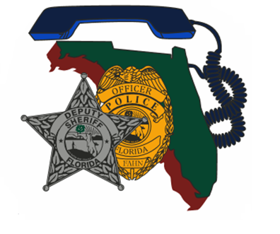  FEB 05, 2024 0800 hours  Police Hostage / Crisis negotiations training  730a-8a Registration and refreshments  8a-12p Case Study: The Arlington Heights Negotiation Debrief  12a-1p Lunch on your own  1p-230p Negotiation Excellence  330p-5p Negotiations Ph.D.  5p Closing discussion, Q&A, networking  Lieutenant Scott Tillema (ret.) is a FBI trained hostage negotiator, with over 20 years of law enforcement experience. He has spent over seven years as a negotiator with the NIPAS Emergency Services Team, one of the largest multi-jurisdictional municipal SWAT teams in the United States.  Educationally, Scott holds a bachelor’s degree in behavioral science and a master’s degree in psychology. Additionally, Scott has received negotiation training though the Harvard University Program on Negotiation and IMD Business School.  In 2016, Scott was invited to give a TED talk, which he titled “The Secrets of Hostage Negotiators” which has received over one million views.  Scott’s professional affiliations include:  ❖ Partner, The Negotiations Collective (Canada)  ❖ Faculty, Schranner Negotiation Institute (Switzerland)  ❖ Founder, Negotiation Excellence, LLC (United States)  This training is free to FAHN members. All others are require to pay a $20.00 FAHN membership fee. | Join us for a presentation by: Scott Tillema  ────  Speaker: Scott Tillema  Hosted by: Region 3 Director Erin Winters  St. Johns County Sheriff’s Office  FAHN Region 3 Director  For Questions:  ewinters@sjso.org  St Johns County Sheriffs Office Emergency communications and traning center  911 Law Enforcement Way  St. Augustine, FL 32092  Mon, Feb 05, 2024 8-5

