Florida Association of Hostage Negotiators  for those who make the call…  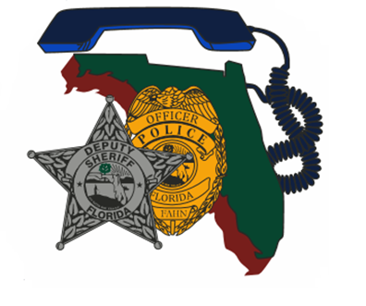  August 24, 2023 8am - 5pm  “BACK TO BASICS tRAINING”  8a-830a……….Welcome/Sign-in  830a-9a……….Training Day Remarks/Rules  9a-10a…………Team Building Exercises  10p-11p……….Refresher Active Listening/Crisis Response  11a-12p……….Prep for Practical Exercise  12p-1p…………Lunch on your 0wn  1p-4p…………..Practical Exercise – Negotiations/Crisis Intervention  4p-5p…………..Debrief/Closing Remarks/Clean-up  Come join us in beautiful Ocala, FL for a full day of negotiations training and a little friendly competition!  Full teams are encouraged to attend, but not necessary. If you attend solo, then you will be assigned to a team for the afternoon practical exercise. Each team should bring their negotiation equipment including: cell phones, computers, throw phone, negotiation supplies, negotiation vehicle, etc.  **This training is free for current FAHN members and $20.00 fee for non-members.**  REGISTER TODAY @ https://fahn.wildapricot.org/Training  Questions? Call Nancy Marzouk at 352-258-5936 (w. cell) | Instructor:  Past FAHN President  Jim Mcdonald  Hosted by:  Marion County  Sheriff’s Office  Location:  Marion County Sheriff’s Office Training Center  692 NW 30th Ave  Ocala, FL 34475

