Florida Association of Hostage Negotiators  for those who make the call…  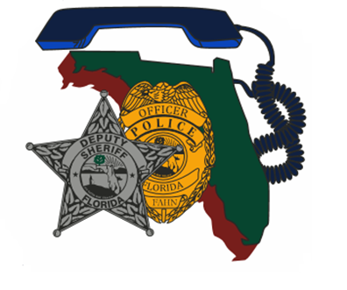  Crisis Management with Individuals with Autism  February 21, 2024 (Wednesday)  7:30a - 5p  (Training will start promptly at 8a.)  7:30a-8:00a…... Sign-in/Training Remarks  8:00a-12:00p.... Identifying Autism/How to Communicate/Case Studies  12:00p-1:30p.... Lunch on your own  1:30p-3:00p...... Local Resources  4:00p-5:00p…… Group Practical Exercise  Individuals with Autism interact with Law Enforcement every day and are often misunderstood or mislabeled as difficult and uncooperative. It is important for LEOs to be able to identify an individual who falls on the spectrum of Autism, and break the communication barriers to obtain necessary information.  Officer Diana Zeitz will build on the identification markers of Autism and how patience is key when communicating with these individuals. Participants will be provided available resources to LEOs and engage in practical exercises to hone learned skills.  ** This training is free for current FAHN members. For non-members, the fee for the training is $20.00. **  REGISTER TODAY @ https://fahn.wildapricot.org/Training  Questions? Call Nancy Marzouk at 352-258-5936 (w. cell) | Instructor:  Officer  Diana Zeitz  Jupiter Police Department  Hosted by:  Alachua County  Sheriff’s Office  Location:  Alachua County Sheriff’s Office  Patrol Squad Room  2621 SE Hawthorne Rd.  Gainesville, FL 32641

