Florida Association of Hostage Negotiators  for those who make the call…  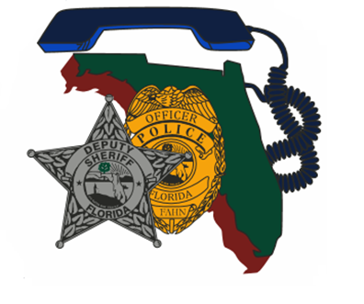  October 08, 2021 from 0800-1700  Conversation starters  Itinerary:  730a-8a F.A.H.N Registration / sign-in and refreshments  8a-1145a Course Presentation  1145a-1p Lunch on your own  1p-5p Group training and presentation close  Course Description:  Conversation Starters is a course designed to prepare negotiators for the beginning of a difficult conversation. Rather than memorizing what to say, this course introduces strategies for starting a conversation and the science behind why those strategies work. Students will discuss:  - In-group / Out-group biases and the effects they have on the negotiator, the subject, and the relationship between the two.  - The three components of empathy, how to recognize which is most appropriate, and how to employ them effectively on the negotiator's behalf.  - Attentional blindness, cognitive capacity, and the critical nature of team participation in a negotiation.  - Improving negotiation tactics and negotiator responses by changing the way we look at the negotiator/subject dialogue.  **Certificates will be provided following the training. For more information, please visit https://www.communicationcynergy.com/ | Join us for an 8- hour Conversation Starter training  ────  Presenter:  Charles (Chuck) Crosby  Communication Cynergy  Hosted by:  Region 5 Director -  Det. Ashley Orndorff  Pasco Sheriff’s Office  FAHN Region 5 Director  For Questions reference FAHN / Course registration:  aorndorff@pascosheriff.org  813-447-9754  *Please send a training request up the chain for approval and registration  Location:  Grace family church  22920 State road 54,  Lutz, Florida 33549  *Cost to Attend: FREE for FAHN Registered Members  Non-members fee: $20.00 per registration

