Florida Association of Hostage Negotiators  for those who make the call…  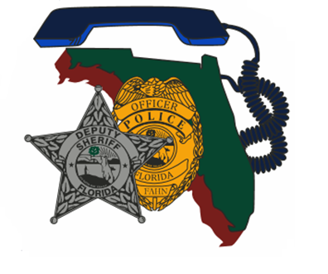  November 1st, 2023 0800-1630  Stress as a Superpower /  Vehicle Pursuit Case Study  730a-8a Registration and refreshments  8a-1145a Natalie Johnson  1145a-1p Lunch on your own  1p-430p Lt. Mark Dainty  Natalie Johnson will present: Keys to High Performance Stress  Although stress is a predominant factor in all our lives, research has revealed that the traditional way we view stress isn’t helpful and contributes to burnout. Science suggests that we can actually use our stress to foster performance, better connect with those that matter, and even extend our life. This training will focus on the updated science of stress and how we can utilize stress as a true superpower. Participants will leave with several strategies they can use immediately in their work and home life.  Lt. Dainty will be presenting the below case study:  On 6/30/23, Highlands County Sheriff’s Office, attempted a motor vehicle stop which resulted in a vehicle pursuit. During the pursuit, 911 calls were received from within the vehicle and an occupant advised she was being held at gunpoint by the other vehicle occupant. The pursuit continued into Polk County where the vehicle ultimately became disabled in an orange grove. Polk County Sheriff’s Office SWAT and CNT were activated, and CNT assumed control of the negotiation.  This training is free for FAHN members!  Or, $20 for non-members (covers membership). | Join us for  Region 7  Training  Speakers: Natalie Johnson (Vidl Solutions) / Lt. Mark Dainty (Polk County S.O)  Hosted by: Carrie Renninger  Manatee County Sheriff's Office  FAHN Region 7 Director  For Questions:  Carrie.Renninger@manateesheriff.com  941-737-3109  MCSO, Distrcit 3  616 67th St Cir E  Bradenton, Fl 34208  November 1st, 2023  0800 am-4:30 pm

