Florida Association of Hostage Negotiators  for those who make the call…  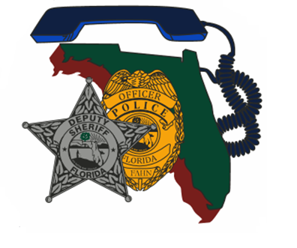  Friday January 20th, 2023  Region 7 and 9 co-host training  Veteran Mental health & Orange County Jail Incident  830a-9a Registration and refreshments  9am -10:15am Veteran Affairs S.A.V.E. Training (Bay Pines Staff)  10:15am - 11:30am Negotiating with Veterans (Sheepdog LLC)  11:30am-1p Lunch on your own  1p-5p Orange County Jail Incident Cpl. Jeffrey James-Potts  *Training is free for FAHN members non-members is $20.00  **Please register for this event on the FAHN website**  For any question, please contact;  Region 7 Training Director Chris Carr (863) 840-1703 Jcarr@highlandssheriff.org  Region 5 Training Director George Mingione (239) 246-7136 George.mingione@aol.com | Join us for an updated look at Veteran Mental Health and a Review of the Orange Co. Jail Incident  ────  Speakers:  Veteran Affairs – Bay Pines,  Sheepdog, LLC,  &  Cpl. Jeffrrey James-Potts  Orange County Sheriff’s Office  ______  Co-Hosted by:  FAHN Region 7 Director Chris Carr  &  FAHN Region 9 Director George Mingione  Training Location:  North Port Fire Rescue (Wellen Park)  19955 Preto Blvd.  Venice, Fl. 34293

