Florida Association of Hostage Negotiators  for those who make the call…  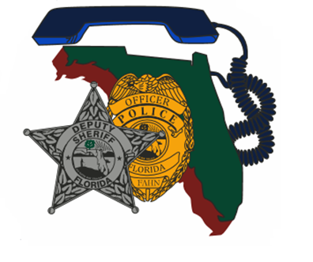  AUGUST 25, 2022 0800-1700  SCENARIO EXERCISE / TEAM BUILDING AND TRAINING / CURRENT ISSUES  0730 - 0800 Registration and Refreshments  0800 - 1145 Scenario and Debrief  1145 - 1300 Lunch on your own  1300 - 1500 Team Development and Training  1500 - 1600 Current Issues  1600 - 1700 Closing and Certificates  “Train, Train, Train”  One of the best ways for us to perform at our highest capabilities is to train. This training is designed to offer your team a scenario to work through and sharpen your skills. Don’t worry if you don’t have your team with you, we can facilitate you in one of the other teams or create a FAHN team. In the afternoon we will discuss team building and training. This will also include an open forum so we all can share and grow as negotiators and negotiation teams. Finally, we will discuss some current topics that we can add to our local trainings. | Join us for a scenario-based training and learning opportunity  ────  Scenario training followed by discussions on team building / training and current issues to work into scenarios  ────  Hosted by: Sgt. Brian Boice  Port St. Lucie Police Department  FAHN Region 8 Director  Contact Info: bboice@cityofpsl.com or 772-204-4557  CHRIST FELLOWSHIP CHURCH  10250 SW Village Pkwy Dr, Port St. Lucie, FL 34987  August 25, 2022, 8am-5pm  This training is free for FAHN members and $20 for non-members (price of new membership)

