Florida Association of Hostage Negotiators  for those who make the call…  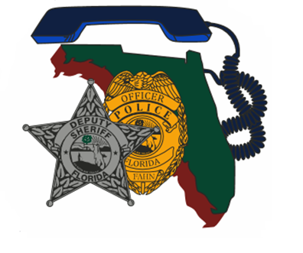  March 27, 2024 0800-1700  presentations by: SWAT commander captain Mike Beath and sergeant brian Boice  0730 - 0800 Registration and Refreshments  0800 - 1200 Bridging the Gap with SWAT Element  1200 - 1300 Lunch on your own  1300 - 1630 Team Building, Development, and Leadership  1630 - 1700 Closing and Certificates  “It is all about the team!”  Your team is a very important part of your agency. Not all agencies and teams are alike. Some negotiation teams feel underutilized, unappreciated, and underfunded. Some teams find themselves in a constant battle with their SWAT element. Come listen and learn how one agency bridged the gap and now operates as one team. You will also be provided with tools, tips, and ideas that you can take back to your teams and watch them grow. | Join us for a great training opportunity!  ────  Bridging the Gap with SWAT with Captain Mike Beath  and  Team Building, Development, and Leadership  ────  Hosted by: Det/Sgt. Brian Boice  Port St. Lucie Police Department  FAHN Region 8 Director  Contact Info: bboice@cityofpsl.com or 772-292-9797  TAMCO  11675 SW Tom Mackie Blvd  Port St. Lucie, FL 34987  March 27, 2024, 8am-5pm  “This training is free for FAHN members and $20 for non-members (price of new membership)”

