Florida Association of Hostage Negotiators
for those who make the call…
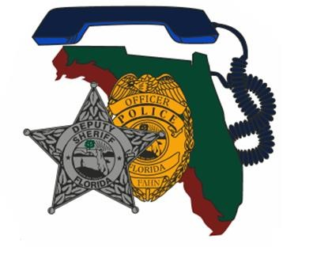
November 17, 2023 0800 – 1600
HNT/CNT Training management

0730 - 0800 Registration and refreshments
0800 - 1130 Presentation
1130 - 1300 Lunch will be provided
1300 - 1500 Presentation
1500 – 1600 Questions
This training will cover effective ways to plan and manage training for Hostage/ Crisis Negotiation Teams.
Topics of discussion will include:
- Relevance -- what skill / topic areas do your teams need to train.
- Building scenarios on actual versus fictional events.
- Creating fleshed out roles with pertinent information.
- Managing and supervising role players.
- Balancing realism and “gameism” in scenarios.
- Working with other entities.
**This training is FREE for FAHN members. Non-FAHN members $20 membership fee**

Join us for HNT/CNT Training Management

────

Learn how to plan and facilitate productive CNT trainings!

────

Speaker:

Paul J. O’Leary

Detective

Hosted by:

Det. Jazmin Correa

Cape Coral Police Department

FAHN Region 9 Director

For Questions:

jcorrea@capecoral.gov

239-242-3714

Cape Coral POlice Department

1100 Cultural Park Blvd
Cape Coral, FL 33990
November 17, 2023 0800 - 1600

