Florida Association of Hostage Negotiators  for those who make the call…  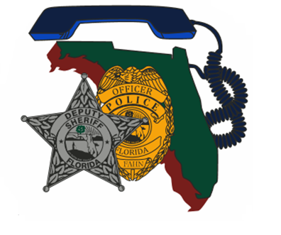  August 1-2, 2022 0830-1630  Advanced Crisis Negotation seminar  Monday, August 1  0830-0900 – Registration and Welcome  0900-1130 – “Us vs. Us: Considerations for Negotiating with Law Enforcement” / SSA Kate Holloway, FBI-CNU  1130-1230 – Lunch  1230-1430 –Two Case Studies on the Challenges of Negotiating with Law Enforcement / Det. Ben Benezette, Port Orange PD  1430-1530 – The Organizational Impact of Law Enforcement Suicide / MPO Jim Whitman, Winter Park PD  1530-1630 – “Effective Debriefing Considerations for Negotiators” / Lt. Chuck Crosby, Orlando PD  Tuesday, August 2  0830-1000 – “Stress, Trauma, and the Pulse Nightclub Attack” by Lt. Chuck Crosby, Orlando PD  1000-1200 – “Open-source Intelligence Gathering” / Heather Perez and Kelly Morrow, Central Florida Intelligence Exchange  1200-1300 – Lunch  1300-1530 – “Open-source Intelligence Gathering” (continued)  1530-1630 – Certificates and Closing Business  This high-quality, sixteen-hour, advanced negotiation seminar is FREE for FAHN members. If you’re not a member, you can attend for $20 and receive a complimentary FAHN membership as a bonus!  Seating limited to the first 40 registrants. Register at:  https://fahn.wildapricot.org/Training | Join us for:  Advanced Crisis Negotiation Seminar  ────  Speakers:  SSA Kate Holloway  FBI-CNU  Det. Ben Benezette  Port Orange PD  MPO Jim Whitman  Winter Park PD  Heather Perez and  Kelly Morrow  CFIX  Hosted by:  Lt. Charles Crosby  Orlando Police Dept.  FAHN Region 6  Training Director  For Questions:  Charles.Crosby@  Orlando.gov  321-299-7077  Orlando police  training facility  100 George Desalvia Way  Orlando, FL 32807  August 1-2, 2022  0830-1630 hours

