Florida Association of Hostage Negotiators  for those who make the call…  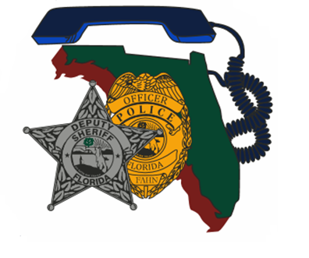  August 27, 2021 0800-1600  Communicating with veterans:  MENTAL HEALTH AND SUICIDE PREVENTION  Morning Session (0800-1130)  A. Introductions, adjustment considerations, discussion  B. PTSD and other clinical issues  C. De-escalation and practical tips, real life scenarios  D. Stigma & suicide prevention within veteran population  E. Help for First Responders under stress  F. Treatment, VA programs & resources  LUNCH: On your own  Afternoon Session (1230-1600)  G. Symptoms, Risk Factors and Suicide Statics  H. Law Enforcement Risk  I. Suicide by Cop, Psychosocial Factors and Stressors  J. Law Enforcement Response to Ongoing Suicide Attempts  K. Non-VA programs and resources; question and answers  This training, designed for First Responders, aims to provide an overview of mental health challenges that Veterans and First Responders may experience, including Post-Traumatic Stress Disorder. Suicide prevention techniques and strategies are also covered. The goal of this training is to help improve engagement strategies when working with Veterans or First Responders who may be in crisis, to strengthen the collaboration between first responders and VA staff, and to help improve access to care.  Seating limited to the first 50 registrants. Register at:  https://fahn.wildapricot.org/Training | Join us for:  Communicating with Veterans: Mental Health and Suicide Prevention  ────  We Will Also Discuss Strategies for Dealing with First Responders in Crisis  Speaker:  Kimberly Canella  Department of  Veterans Affairs  Hosted by:  Lt. Charles Crosby  Orlando Police Dept.  FAHN Region 6  Training Director  For Questions:  Charles.Crosby@Orlando.gov  321-299-7077  Orlando police  training facility  100 George Desalvia Way  Orlando, FL 32807  August 27, 2021  0800-1600 hours

