Florida Association of Hostage Negotiators  for those who make the call…  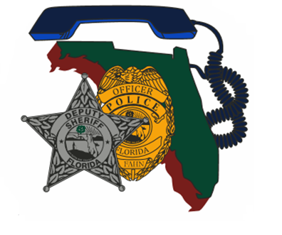  Oct 19, 2022 0900 Hours  The Boy in the bunker presentation/Scenario based training  8a-9a Registration and refreshments  9a-1145a The Boy in the Bunker Presentation  1145a-1p Lunch on your own  1p-3p Scenario Based Roleplaying w/ Nova Southeastern  University Psychology Students  3p-4p Current Issues & Concerns  4p-5p Certificates & Dismissal  The Boy in the Bunker case is an incredible law enforcement success and inspirational story. Jim Dykes boarded a school bus in rural Alabama and shot the driver. He then abducted an innocent 5 year old boy and took him to his underground bunker where he kept hundreds of law enforcement at bay for 7 days.  See dramatic videos from the bus, listen to the actual hostage negotiations, and witness the heroic resolution captured from above. Tactical and negotiators worked hand in hand and expended Herculean efforts to save one child. | Join us for a presentation by the FBI  ────  We will also have  Scenario Training  ────  Speaker: Kyle Vowinkel  FBI Assistant Special Agent in Charge  Hosted by: Ofc. Mark Pollman & Sgt. David Garcia  Plantation & Davie PD  FAHN Region 10 Director  For Questions:  DGarcia@Davie-FL.Gov  954-693-8086  Volunteer Park Community Center  12050 W Sunrise Blvd  Plantation, Fl 33323  Wed, Oct, 19, 2022 @ 0900  This training is free for FAHN members and $20 for non-members (price of new membership)

