Florida Association of Hostage Negotiators  for those who make the call…  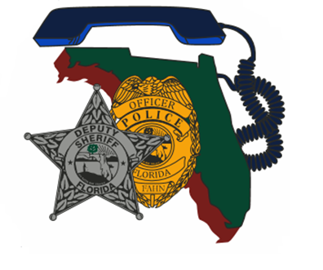  Thursday December 9th 2021  Mental health in the united states  730a-8a Registration and refreshments  8a-12p Mental Health/Scenarios  12p-1p Lunch on your own  1p-5p Mental Health/Scenarios  *Training is free for FAHN members non-members is $20.00  “Just as CPR helps you assist an individual having a heart attack, Mental Health First Aid helps you assist someone experiencing a mental health or substance use-related crisis. In the Mental Health First Aid course, you learn risk factors and warning signs for mental health and addiction concerns, strategies for how to help someone in both crisis and non-crisis situations, and where to turn for help”.  *Parking is available free of charge within the park*  Contact: MPO Rade Momirovich 561-685-9028  Email: rmomirovich@wpb.org | Join us for an in-depth look at Mental Health Issues in the United States:  ────  Presented by Mental Health First Aid USA.  ────  Speaker: Lt Sterling Kihei, WPBPD  Mary V. McDonald Wilson Center.  Hosted by: Regional 8 Director Rade Momirovich  West Palm Beach Police Department  FAHN Region 8 Director  Mary V. McDonald Wilson Center. Gaines Park. 1501 N Australian Ave, WPB, FL 33401  (561) 804-4960  Thursday December 9th 2021, 8am-5pm

