Florida Association of Hostage Negotiators  for those who make the call…  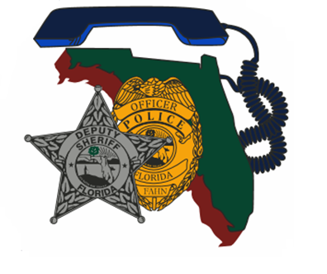  Monday November 14, 2022 8:00am – 4:00pm  Negotiator self care  8:00am – 8:30am……..Registration  8:30am – 12:00pm……Session 1  12:00pm – 1:00pm……Lunch on your own  1:00pm – 4:00pm……..Session 2  Dr. Klimley is a proven professional in the mental fitness and improved resiliency treatment for first responders. Their goal is to assist first responders to serve their community and also build their own personal resiliency.  Participants will get an indepth discussion on internal de-escalation, stress reactions, post-negotiations self-care, cognitive strategies and building long-term resilience. Participants will be able to use the knowledge gained to better understand self-care while on scene, immediate after-care, and long-term health.  - Registration fee: Free for FAHN members; $20 for non-members (includes one year membership).  - Registration deadline is: November 4th, 2022  - Register here: https://fahn.wildapricot.org | Join us for:  A day of negotiator self-care techniques.  ────  Topics targeted will be:  On scene internal de-escalation  Post-negotiation self-care  Building long-term resilience  ────  Speaker: Dr. Kristin Klimley  Tampa Bay Psychology Association  Hosted by: Damian Threet & Nancy Marzouk  St. Johns / Alachua County Sheriff’s Office’s  FAHN Region 3 & 4 Directors  For Questions:  nmarzouk@acso.us  352 258-5936  dthreet@sjso.org  904-687-5511  UF/IFAS, The T. Jesse Godbold Extension Educaiton Building,  2463 SR 16 W, Green Cove Springs, FL 32043  << can add a web address if relevant for site>>  <<Date and Time>>

