Florida Association of Hostage Negotiators  for those who make the call…  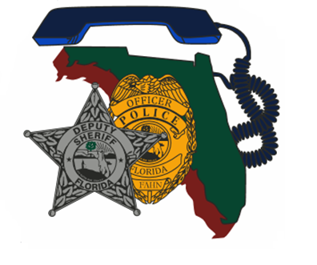  Monday March 13, 2023 8A-5p  Surviving psychological injuries  Building Wellness & Resiliency  Itinerary:  8a-830a F.A.H.N Registration / sign-in and refreshments  830a-1145a Course Presentation  1145a-1p Lunch on your own  1p-5p Course Presentation Cont. / Networking / Closing  Course Description:  After years in law enforcement with little to no real training on how to stay mentally and physically healthy, Responder 1st was started. Through the mistakes and failures of careers and marriages, we as peers and clinicians share our personal and professional lessons learned and potential pitfalls of critical incident stress.  This training will address the unique stressors related to law enforcement officers and the effects on physical performance, mental performance, and relationships. We will offer practical tools and strategies that will enhance your existing resiliency.  Training Points Include:  - Cumulative Stress  - Vicarious Trauma  - Physical/Mental Health  - Marriage/Relationship Health  - Building Practical Resiliency  ***Training Certificates will be provided electronically*** | Join us for an 8- hour  Surviving Psychological Injuries  Building wellness & resiliency  ────  Presenters:  Greg Dawson  Kasie Dawson, LPC, CFRC  Responder 1st  Hosted by:  Region 2 Director -  Lt. Jason Glover  Leon County Sheriff’s Office  FAHN Region 2 Director  For Questions reference FAHN / Course registration:  gloverj@leoncountyfl.gov  850-556-2930  *Please send a training request up the chain for approval and registration  Location:  Florida Sheriff’s Association  2617 Mahan Drive  Tallahassee, fl 32308  *Cost to Attend: FREE to FAHN members  $20 if Non-FAHN Member

