Florida Association of Hostage Negotiators  for those who make the call…  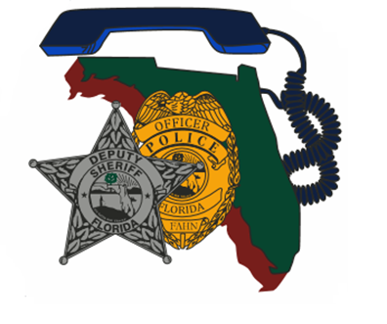  April 18, 2024 0800-1700  case debriefs of crashed in the orange groves and canadian scorned by exotic dancers  7:30a-8a Registration and refreshments  8a-10a Case Study from Polk County Lt. Mark Dainty  10a-12a Case Study from Hillsborough County Sgt. Aaron Dahl  12p-1:15p Lunch on your own  1:15p-5p Breakout Scenario Training Session  First case study will cover negotiating during a hostage situation within a vehicle crashed into the orange groves after a pursuit. Lt. Mark Dainty will provide details of the case and discuss positives/negatives learned from the situation.  Second case study will cover negotiating with a Canadian citizen scorned by his exotic dancing girlfriend haiving an affair. Sgt. Aaron Dahl with provide the details of the case and discuss lessons learned from the incident.  In the afternoon groups will break out into negotiation teams and actively engage in a training scenario. Afterward, teams will reconvene and discuss tactics used as well as lessons learned. | Join us for two unique case study reviews from Hillsborough County SO and Polk County SO.  ────  We will also break out into teams for a training scenario and compare/contrast team tactics.  ────  Speakers: Lt. Mark Dainty; Polk County Sheriff’s Office and Sgt. Aaron Dahl; Hillsborough County Sheriff’s Office  Hosted by: Steve Jacobsen  Pinellas County Sheriff’s Office  FAHN Region 5 Director  For Questions:  sjacobsen@pcsonet.com  727-582-6333  This training is FREE for FAHN members. $20 for non-members (covers new membership)  ***VENUE CHANGE***  Tampa convention center RM 124-125  333 S. FRANKLIN ST  TAMPA, FL 33602  << can add a web address if relevant for site>>  <<Date and Time>>

