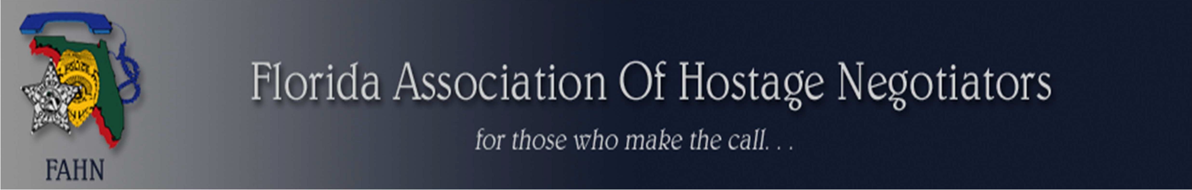

FAHN 2018 ANNUAL CONFERENCE

June 4 – 8, 2018

It will again take place in the vibrant Bayfront district of St Petersburg.
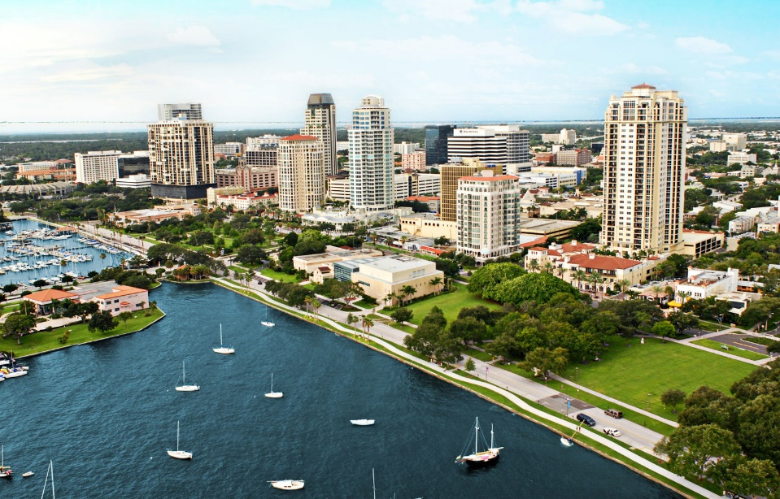
FAHN is again delivering high quality training sessions in a format delivering useful content by engaging speakers.

Breakout sessions will ensure you are able to choose your own program and much of the content will be available in parallel presentations.

This year, JD Byas will be on hand to present the Dallas incident from 2016. Just a highlight in a week of case studies, specialized instruction, and discussions which are sure to add significantly to your toolbox.

For FAHN members, we are also maintaining our last year's fees of $225.00. So register early.

Register on-line by going to: www.fahn.net

For more information, contact:

Sheldon York
FAHN SECRETARY
P.O.BOX 781861
Orlando, FL 32878

syork@sjso.org
904.392.9307

